Chapter 2: Analysis

2.1 Analysis Introduction
A detailed study of anything in order to understand its nature and to determine the features is known as analysis. Analysis first step is to collect all the requirements and function required for the project to complete. It also helps in identifying the problems and helps to overcome the problems. Diagram such as use case and class diagram are used in analysis phase to visualize the features and function of the system in a diagrammatic way for better understanding.

2.2 Analysis methodology- Hard approach methodology
For my project, I am using hard approach methodology because it is used to identify the problems or new opportunities and also hard approach is a method which can be used on every system analysis whether it is large system or small so I have used this analysis method.

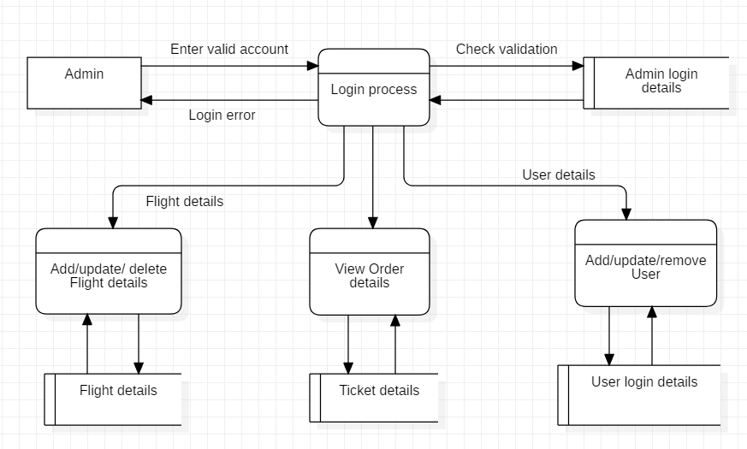
Figure 1: DFD of admin
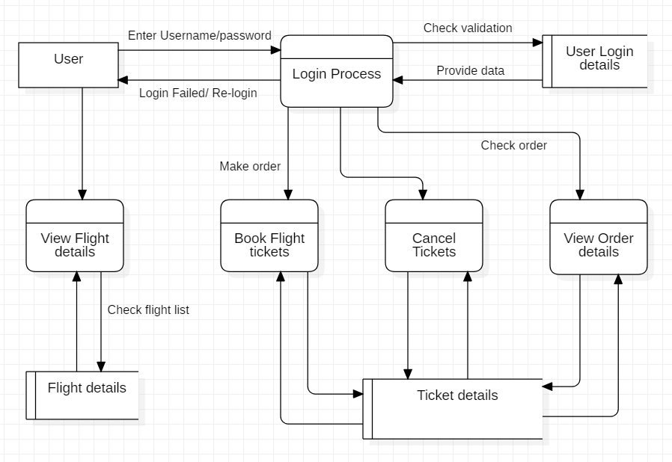
Figure 2: DFD of user

2.3 Information Gathering Methodology
Managing or collecting the necessary information through different method for the project activities and process is known as information gathering methodology. For this project I have chosen questionnaires and interview.
- Questionnaires
It the way of collecting the information from the people by providing the list of question either orally or in written form. I chose questionnaires as it is cheaper than other method. It is also the fast and easy way of gathering information. I have asked some questions to some individuals regarding their view in the system,
 | Very Satisfaction | Somewhat Satisfied | Neutral | Somewhat Unsatisfied | Very Unsatisfied
Ease of Installation
Hardware Compatibility
Operating System Compatibility
Consistency with Interface
Application Software Compatibility
Completeness and Organization of Documentation
Clarity of Documentation
Accessibility of Product Support
Quality of Product Support
Value Relative to Cost
Overall Reliability
Overall Performance

2.4 Feasibility Study
It is the practical way of analyzing whether the requirement gather to run the project successfully is suitable or not and workable. It is done to provide user with the software that is acceptable, adaptable to change and comfortable. Feasibility Study helps to examine whether the project is technically, financially and socially feasible.
There are different types of feasibility study which are discussed below:-
- Technical feasibility: Technical feasibility is the process of validating that the technology used in the project requirement is technically fit for the project. It helps to identify whether the process or procedure used in the project is convenient or not. Similarly, our system is technically feasible because we have the required gadgets and technologies which will help us in the development phrase of this system.

- Economic feasibility: Economic feasibility is related with the financial constraint. It helps to validate that the given project is possible within the estimated budget. It help an organization with the cost analysis to develop the software. If the development process is above the estimated cost than this process will help to find the best solution. Similarly, this system will be economically feasible because we have already calculated the total time to develop and the cost. Also we would be using the budget which is provided by client themselves and will work under the budget.

- Legal feasibility: It deals with the legal issue of the system. It ensures that the government rules and regulations are legally followed and make sure that the project will meet all the legal requirement before completing project. As, many software faces legally issues after deployment but we have already consulted to the legal personals so that our software will not face any legal actions and would be legally feasible.

- Time/ Schedule: It deals with the time constraints of the developing process. It determine the time estimation of the project is reasonable. It make sure the project is completed in time. For my project I have allocated 4 month maximum to complete the project. For this I have divided the task in order to complete the task more efficiently. I estimated 28 days for analysis, 23 days for design part, 20 days for coding, 6 days for testing and 10 days for the final documentation. So completing the project in the estimated is very important.

- Social feasibility: It is one of the important part of feasibility study which determine the acceptance of the people regarding the new system. It helps to identify whether the new system will hinder the society or not and make sure the people are retrain to adapt with the new system. Our management system would be socially feasible because we have already done some questionnaires and interviews regarding what people want in the system to be socially fit.

2.5 SRS
SRS stand for software requirement specification. It is the description of the system with its functional and non- functional requirement. It helps to record all necessary requirement required for the development of the project. The types of requirement needed for the development process are as follows:
- Functional Requirement
Functional requirement specifies the process and function of the system. Functionality of the system must be clear before development of system. I have chosen questionnaires and interview to collect all the requirement necessary for the system.
Some of the functional requirement with MoSCoW Prioritization are listed below:

Id | Title | Description | Rational | MoSCoW | Dependency
A1 | Registration | User should be able to create a new account. | To create a new account in order to access in the system. | Must have | N/A
A2 | Login | User should be able to login in to the system. | To get direct exit to the system using their previous account. | Must have | A1
A3 | Admin login | Admin should be able login to the system. | To get access to the admin panel. | Must Have | N/A
A4 | View flight details | User and admin both can view the flight details. | To view all the records of flight. | Must have | A1,A2,A3
A5 | Add user record | User should be able to add their personal details. | To add personal details. | Should have | A2
A6 | Sending and viewing message | User should be able to send the message or feedback where admin should be able to view the message. | To send and view the message or feedback regarding the system. | Should have | A2, A1,A3
A7 | Add flight details | Admin should be able to add the details record of flight. | To add flight schedule for the passenger. | Must have | A2, A3
A8 | Delete flight details | Admin can delete the flight schedule. | To delete the flight schedule after its intake. | Should have | A3, A7
A9 | Book ticket | User should be able to book the ticket. | To book the ticket of flight. | Must have | A2, A4
A10 | Update flight details | Admin should be able to update the flight details. | To update flight detail time-to-time. | Must have | A3
A11 | View Order | Admin should be able to view the order of ticket. | To view the ticket order for further procedure. | Must have | A3
A12 | Cancel order | User should be able to cancel the order. | To cancel the booking of flight. | Should have | A2, A9
A13 | View history | User should be able to view their booking history. | To view the history of booking. | Could have | A2, A9
A14 | Send email confirmation | Admin should be able to send message to user via email. | To send confirmation to user through email. | Won't have | A3
A15 | Generate bill | User must get a bill after booking tickets. | To generate bill. | Won't have | A2, A9

- Non- functional Requirement
Some of the non-functional requirement with MoSCoW Prioritization are as follows:
Id | Title | MoSCoW | Description
N1 | Usability | Must Have | The system should be useable for all the users. The requirements of the client should be fulfilled while developing the system to make it useable for everyone.
N2 | Security | Must have | Security of data is must important aspect. Only the valid user can use the system.
N3 | Performance | Must have | Good performance is necessary in order to get the output in real-time speed. There should not be any kind of delay while running the system.
N4 | Reliability | Must have | Software failure may occur so, this function describes about the failures of software and also concerns the solution for this failure. It helps to specify error in the system.
N5 | Maintainability | Must have | Errors and bugs can occur in the system so, maintainable of the system is very important to fix the issues occur in the system.
N6 | User friendly | Should have | User satisfaction is very important so the software must be user friendly. User friendly software is easy to use and it improves performance.
N7 | Availability | Must have | The system is available at any time. User can access to the system using browser at any place.
N8 | Serviceability  (Supportability) | Should have | The system should provide great services to the user so that they can improve their performance. The system should be supportive to improve the works of clients and to handle the errors
N9 | Scalability | Must have | Scalability means handling the increasing or changing amount of work or data in the system. The data in system increase with the time interval so the system must be able to change or add new resources.

- Hardware Requirement
Processor: Pentium 4 2GHZ above
Ram: 2GB above
Monitor: VGA Color Monitor

- Software Requirement
Operating system: Windows 7 above
Developing tool: Notepad++, PHP my admin
Database: PHP my admin

2.6 Use case diagram
Use case diagram is the dynamic or behavioural diagram which helps to demonstrate the different ways of how the user will interact with the system. It is very helpful while developing the system as it helps to collect the functional requirements of the system. Below is the use case diagram of this project :
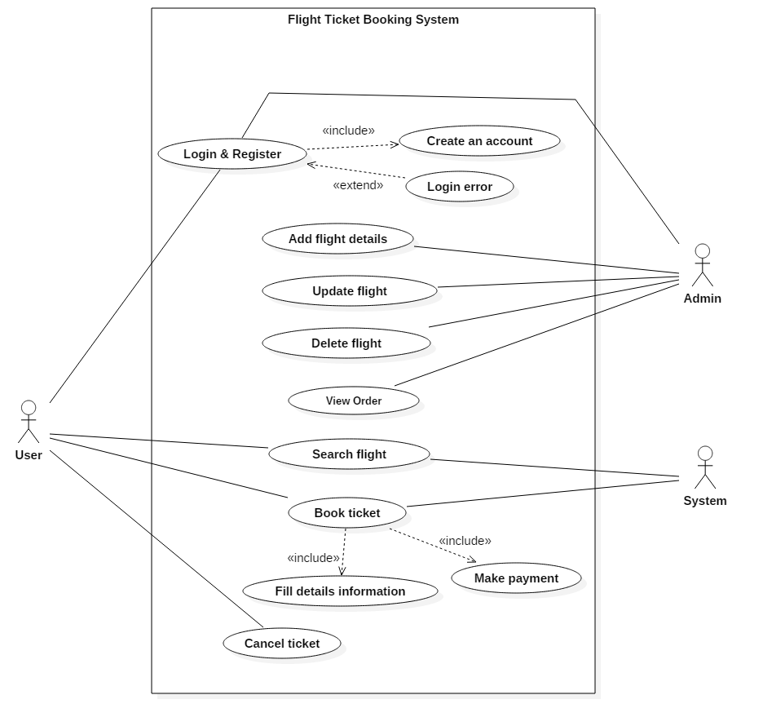
Figure 3: Use case diagram

In this diagram, User, admin and system are the primary actor who interact with the system function. User of the system are those who use this system or can say an owner or client. They must create a new account or login directly to enter into the system. They can also book the flight ticket according to their destination. Admin are those who manages the system and checks the order of tickets to conform the reservation. Admin also should be logged in to get access to the admin panel.

- Login
This helps the user and admin to get access to the system. If the user have their account they can directly login but if they don’t have an account they can create a new account and can use the system.

- Add flight details
This function means adding the flight details information like flight name, destination, time interval etc. by the admin in the website which can be later viewed by the customer.

- Update flight details
This is used to update the flight information by admin. Sometimes the flight can be delayed due to some reasons so the flight time need to be updated every time.
- Search flight
This function is used to search or to view the flight details by the user to book the flight according to the destination. All the details information about the flight are mentioned in this function.
- Book ticket
After viewing the flight, user can book the ticket for reservation. User must fill all the details information of the passengers and also make online payment for the ticket.
- Cancel ticket
This function is used to cancel the ticket which was booked by the user earlier. For using this function user must be logged in to the system.

2.7 System architecture
System architecture defines the structure and behavior of the system. I have chosen 3-tier architecture for this project. I have chosen this architecture because it is flexible and provide security as the user don’t use the database directly. This architecture is easy to maintain and understand and also object oriented concept can be easily applied in the system. It is a client server architecture with 3 tiers- presentation tier, application tier and data tier.
- Presentation tier:-A graphical user interface (GUI) built with HTML, CSS and JavaScript.
- Application tier:-It is written in Java language which handles logic and supports applications core functions.
- Data tier:-Also known as storage tier. It consists database and program for managing read and write access to database.
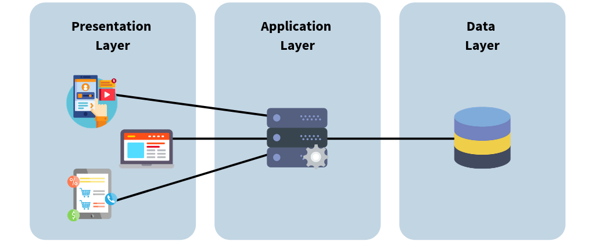
Figure 4: 3-tier architecture

2.8 Class Diagram

2.8.1 Scenario
Flight ticket booking system is a system which is used to make the reservation of the flights tickets online. The system must have the features like registration and login to make the booking. This system must have an online method of payment of the tickets. In this system the admin should be able to edit, change or delete the booking and the flight time also the admin must have the access to reschedule the flight time. Once the user are logged in they should be able to insert, update and delete their personal details and also view the flight list.

2.8.2 NLA
Natural Language Analysis is the procedure of recognition of nouns, verbs as well as adjectives and then convert it to classes, attributes and methods. Some of the rules for designing NLA are:
- All the possible nouns for candidate classes are listed.
- Duplicate classes are removed.
- Unrelated classes are removed.
- Listing synonyms classes.

- Noun
List of candidate class
- Flight  - Ticket  - System  - System  - Reservation  - Flight  - Tickets  - System  - Registration  - Login  - Booking  - Time  - User | - System  - Method  - Payment  - Tickets  - System  - Admin  - Booking  - Flight  - Time  - Admin  - Access  - Flight  - Flight list

Duplicate candidate functionality removed
- Flight  - Ticket  - System  - Reservation  - Registration  - Login  - Booking | - Time  - User  - Admin  - Method  - Payment  - Access  - Flight list

Irrelevant classes removed
- System  - Reservation  - Booking  - User  - Admin | - Payment  - Flight List  - Ticket

- Synonyms
- Booking = Reservation

Selected Candidate class
- System
- User
- Admin
- Payment
- Ticket
- Flight list

- Verb

List of Verbs
- Used  - Make  - Online  - Must  - Have  - Must  - Have  - Should  - Edit | - Change  - Delete  - Must  - Have  - Reschedule  - Logged  - Insert  - Update  - Delete  - View

Duplicate candidate functionality removed
- Used  - Make  - Online  - Have  - Should  - Edit  - Change | - Delete  - Must  - Reschedule  - Logged  - Insert  - Update  - View

Irrelevant method removed
- Edit  - Change  - Delete  - Insert | - Reschedule  - Logged  - Update  - View

- Synonyms
- Update = Edit/ Change/ Reschedule
Selected methods
- Update
- Insert
- Logged
- View
- Delete

2.8.3 Class Diagram
Class diagram is the static diagram which defines the structure of the system by showing system classes, their attributes and methods and relation between them. It is very helpful for the team member and developers to understand the system more easily. It can also be useful for object-oriented concept.
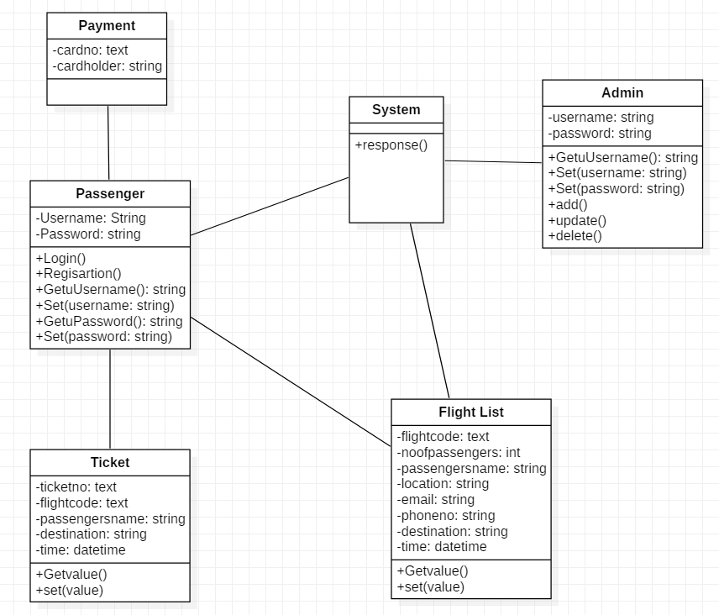
Figure 5: Initial class diagram

